*PRESENTATION EVALUATION ASSIGNMENT*

1. As a group, evaluate how well the team did in each of the four areas described below. For each of the four areas, assign a number value that represents how well the team did in that area. The judge team members should discuss to give the final scores for each of the four areas.
2. **Sample evaluation entry (Score + Comment) see the third page in the document.**
3. Presentation style checklist is for your reference. Not required to fill it out.

In assigning a number grade to each aspect below, use the following scale:

|  |  |  |
| --- | --- | --- |
| 10 Outstanding—in top 5% of all presentations |  | 5 About average |
| 9 |  | 4 |
| 8 Excellent—in top 15% of all presentations |  | 3 Needs lots of work |
| 7 |  | 2 |
| 6 Good—above average but room for improvement |  | 1 We are embarrassed |

**____ Presentation Style**

See checklist on the next page. It is not necessary to turn in the checklist; it is for your guidance only.

**____ Content**

Was the information presented in a logical and organized manner?

Was the amount of information presented too much? too little? about right?

Was enough information about methods provided to judge the quality of the research?

Were important points clearly identified?

Were questions handled well?

**____ Visual Aids**

Were visual aids completely legible?

Was the number of visual aids too few, too many, about right?

Were the visual effective in communicating or illustrating major points?

Did the visuals follow guidelines described in class?

**____ Creativity and Interest**

Did presenters use an effective “hook” at the beginning to generate audience interest?

Did the presentation maintain audience interest?

Did the visual aids show creativity or were otherwise effective in maintaining interest?

Was anything special done to make the presentation effective & interesting?

|  |  |  |  |  |
| --- | --- | --- | --- | --- |
| ***Presentation Style Checklist*** | | | | |
|  |  |  |  |  |
|  | Presenter 1 | Presenter 2 | Presenter 3 | Presenter 4 |
|  |  |  |  |  |
| Were the presenters in professional dress? |  |  |  |  |
|  |  |  |  |  |
| **Eye contact** |  |  |  |  |
| Any problems with: |  |  |  |  |
| • Looking at notes too much |  |  |  |  |
| • Looking at floor |  |  |  |  |
| • Looking at the computer too much |  |  |  |  |
| • Looking back at screen |  |  |  |  |
| • Looking at the professor too much |  |  |  |  |
| • Looking at only part of the audience |  |  |  |  |
|  |  |  |  |  |
| **Posture** |  |  |  |  |
| Any problems with: |  |  |  |  |
| • Slouching |  |  |  |  |
| • Leaning on lectern |  |  |  |  |
| • Leaning on one hip |  |  |  |  |
| • Keeping one or both hands in pocket(s) |  |  |  |  |
| • Crossing legs while standing |  |  |  |  |
| • Swaying side to side or forward and back |  |  |  |  |
|  |  |  |  |  |
| **Voice, speaking style** |  |  |  |  |
| Any problems with: |  |  |  |  |
| • Speaking too loudly |  |  |  |  |
| • Speaking too softly |  |  |  |  |
| • Speaking in monotone |  |  |  |  |
| • Mumbling |  |  |  |  |
| • Um, uh, "you know," "like," etc. |  |  |  |  |
| • Choppy speaking style |  |  |  |  |
| • Lack of enthusiasm |  |  |  |  |
| • Spoke too fast |  |  |  |  |
| • Spoke too slowly |  |  |  |  |
| • Sped up or slowed down at the end |  |  |  |  |
| • Long pauses |  |  |  |  |
| • Too many pauses |  |  |  |  |
| • Distracting mannerisms |  |  |  |  |
|  |  |  |  |  |
| **Preparation** |  |  |  |  |
| Any problems with: |  |  |  |  |
| • Too much reliance on notes |  |  |  |  |
| • Obtrusive notes |  |  |  |  |
| • Lost track of place |  |  |  |  |
| • Poorly planned transitions between speakers |  |  |  |  |
| • Unfamiliarity with equipment |  |  |  |  |
| • Inadequate knowledge of equipment or software |  |  |  |  |
| • Didn't seem comfortable with the material |  |  |  |  |
| • Did the presenter seem knowledgeable? |  |  |  |  |
| • Did the presenter seem confident and convincing? |  |  |  |  |

**Sample evaluation entry**

Presenting teams: Judge team

[Team1:](https://docs.google.com/spreadsheets/d/1_kRvdRYMoA6t67Z_5ECWnuBofxJ8_doPWwJXMaSuRXc/edit?usp=sharing) 2,3,4,5

[Team2:](https://docs.google.com/spreadsheets/d/1duFaej7tw_52nOeZf0H5i-yV_ubVTFAjKJaLiPDe58w/edit?usp=sharing)  3,4,5,6

[Team3:](https://docs.google.com/spreadsheets/d/1eaKTscJ1I3yHP0n3CAj9pG2j7WcyfMuPOo2fKAffFb4/edit?usp=sharing)  4,5,6,1

[Team4:](https://docs.google.com/spreadsheets/d/1yB8vKVCuqYUV7kLPY4FaNXflIYNTYZqo7ipxht1a8WU/edit?usp=sharing) 5,6,1,2

[Team5:](https://docs.google.com/spreadsheets/d/12zP1Qtj2KUXGs_jFuB1alBOwav-9wgI-5mL8bEFVWAc/edit?usp=sharing) 6,1,2,3

[Team6:](https://docs.google.com/spreadsheets/d/1fqz7noCUuTWaJJvn5X9EJBcKnX1ruvDqNwAVKZs5bwM/edit?usp=sharing) 1,2,3, 4

Submit the scores through the google sheet link on the presentation teams in the format below. Each presentation team will be evaluated by four other teams. Each team’s final score will be the combined score between mine and peer team evaluations. **for example:**

Team 3, 4, 5, 6 will judge the Team 2’s performance per the pairing table above.

You can access the presentation recording by clicking the **‘presentation team #’** hyperlink

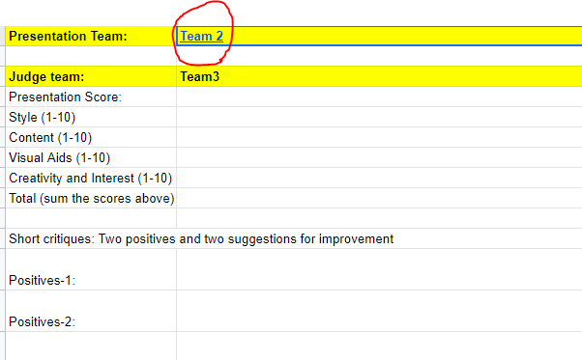

**Judge:** Team 3

Presentation team: 2:

Presentation Score: Style 8, Content: 10, Visual Aids 7, Creativity and Interest 9

Total Score: 8+9+8+7 = 32

Short critiques: Two positives and two suggestions for improvement

Positives: 1) All the members were very enthusiastic about the project 2) The difference test was done correctly with good recommendations to the client based on the finding.

Suggestions: 1) The chart was pasted from Qualtrics directly, it should be formatted for the presentation. 2) One of the presenters was reading from a script and not looking at the webcam.